DATA HANDLING AND VISUALIZATION
Name: Sri Mathi S
Reg no:192424095
Experiment_2
Set 5
Dataset: Website Traffic
- Create a line chart to visualize the trend in daily page views over time. Label the axes and title the chart.
- Generate a bar chart showing the top N days with the highest click-through rates. Label the chart elements.
3. Develop a stacked area chart to display the distribution of user interactions (likes, shares,comments) on a website.
4. Build a Tableau dashboard with the line chart and bar chart for interactive exploration of website traffic data.
PROCEDURE:
- Open Tableau Desktop.
- Connect to the Excel file containing the Website Traffic dataset.
- Verify that the data is imported correctly.
- Create a line chart by placing Date on the Columns shelf and Page Views on the Rows shelf. Select Line as the chart type.
- Create a bar chart by placing Date on the Columns shelf and Click-through Rate on the Rows shelf. Sort the values in descending order and display labels.
- Add sample fields for Likes, Shares, and Comments if they are not available in the dataset.
- Create a stacked area chart using Date on Columns, interaction values on Rows, and interaction type on Color.
- Create a Dashboard and add the line chart and bar chart.
- Format the dashboard by adding titles, legends, and filters if required.
- Save the workbook.
OUTPUT:
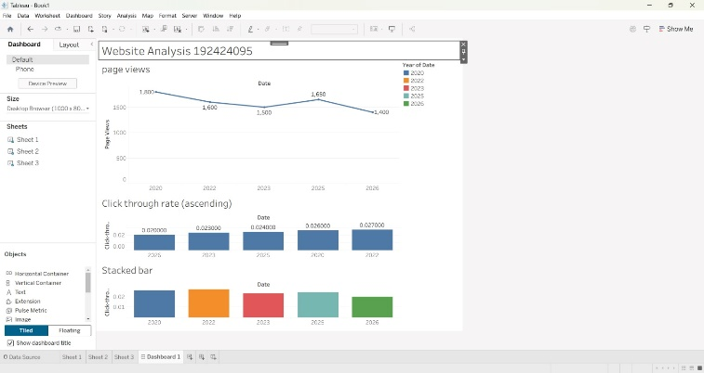
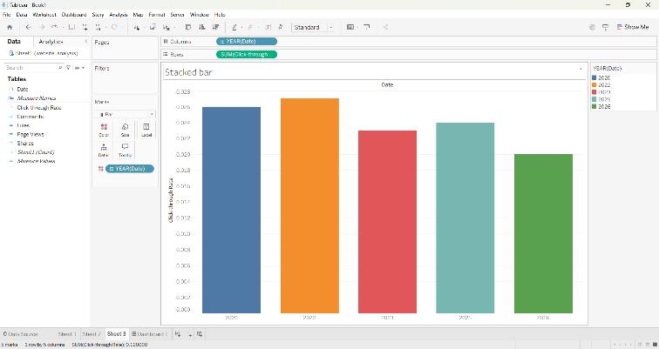
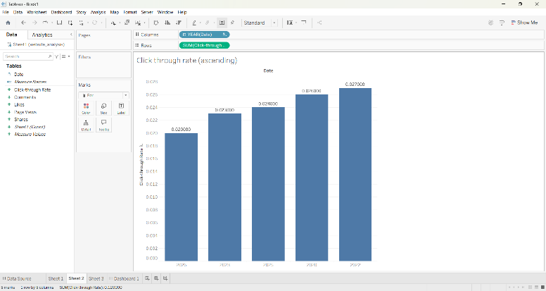
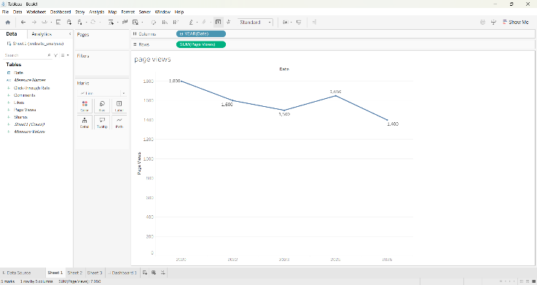
Set 6
Dataset: Monthly Product Sales
- Create a grouped bar chart to visualize the sales of each product for the first quarter. Label the chart elements.
- Generate a stacked area chart to represent the overall sales trend for all products over the three months.
- Build a table to show the monthly sales data for each product. Label the table elements.
- Develop a Tableau dashboard combining the grouped bar chart, stacked area chart, and the table for interactive exploration of sales data.
PROCEDURE:
- Open Tableau Desktop.
- Connect to the Monthly Product Sales dataset.
- Import the data into Tableau.
- Pivot the monthly sales columns (January, February, and March) if required.
- Create a grouped bar chart by placing Product Name on Columns, Sales on Rows, and Month on Color.
- Create a stacked area chart using Month on Columns, Sales on Rows, and Product Name on Color.
- Create a table by displaying Product Name along with January, February, and March sales.
- Create a Dashboard and add the grouped bar chart, stacked area chart, and table.
- Arrange the visualizations neatly and add titles.
- Save the Tableau workbook.
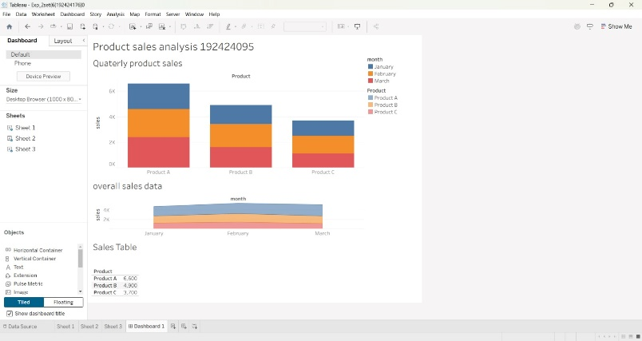
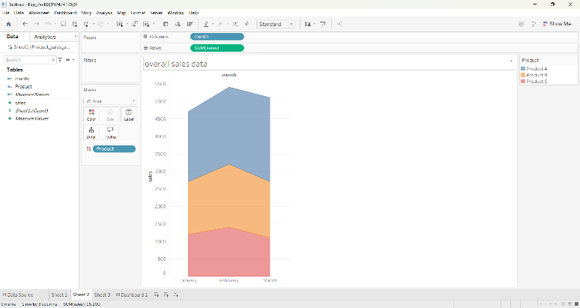
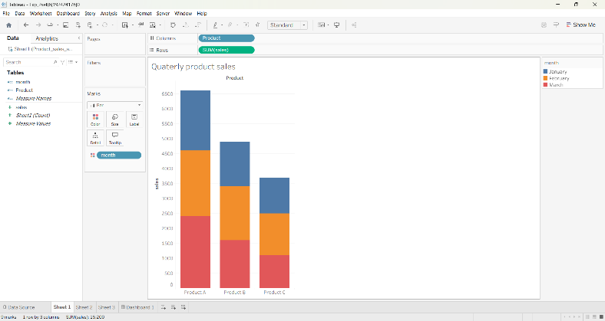
OUTPUT
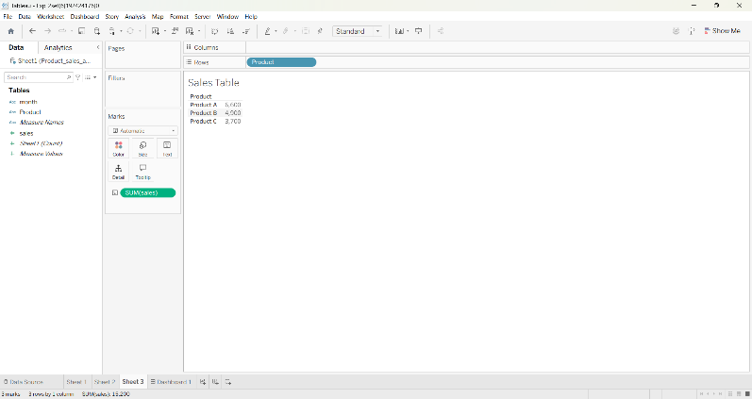
Set 7
Dataset: Customer Demographics
1.Create a bar chart to visualize the distribution of customer ages. Label the axes and title the chart.
2. Generate a pie chart to represent the distribution of customers by gender.
3. Build a table to show the demographic information for each customer. Label the table
elements.
4. Develop a Tableau dashboard combining the bar chart, pie chart, and the table for
interactive exploration of customer demographics.
PROCEDURE:
- Open Tableau Desktop.
- Connect to the Customer Demographics dataset.
- Verify that all fields are imported correctly.
- Create a bar chart by placing Customer ID on Columns and Age on Rows.
- Create a pie chart by placing Gender on Color and COUNT(Customer ID) on Angle and Label.
- Create a table displaying Customer ID, Age, Gender, and Income.
- Create a Dashboard and add the bar chart, pie chart, and table.
- Arrange the charts properly and include titles and legends.
- Add filters if required for interactive analysis.
- Save the Tableau workbook.
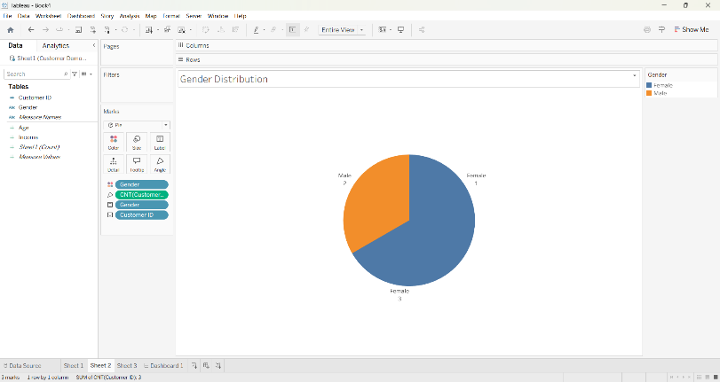
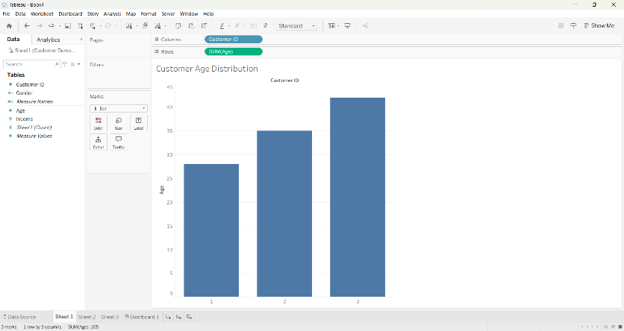
OUTPUT:
